**HTML forms: best practices**

**1 - Creating accessible forms**

Forms are commonly used to enable user interaction within Web sites and Web applications, for example, for login, registering, commenting, and purchasing.

Since HTML5 provides functionalities to assist with accessibility, developers should make a concerted effort to mark up Web based forms. The following two guidelines are to give you a good start to make your forms accessible:

1. For every form field, ensure that a descriptive **label** is provided and use the <label> element to identify each form control.
2. For larger or complex forms, use the <fieldset> and <legend> elements to respectively **group and associate** related form controls.

We will give usage examples for each of these two basic guidelines in the following pages.

**Further reading**

The WAI Web site hosts a [Forms tutorial](http://www.w3.org/WAI/tutorials/forms/) where you will find more guidelines to help make your forms truly accessible: Form Instructions, Validating Input, User Notifications, Multi-Page Forms, and Custom Controls.

Link - <https://www.w3.org/WAI/tutorials/forms/>

Link - <https://developer.mozilla.org/en-US/docs/Learn/HTML/Forms/How_to_structure_an_HTML_form>

Link - [https://www.w3.org/WAI/tutorials/forms/grouping/?course=#](https://www.w3.org/WAI/tutorials/forms/grouping/?course=)

Link - <https://oscarcao.com/blog/2015/06/08/introduction-to-understanding-wai-aria-1-0-roles/>

### [HTML forms and JavaScript](https://courses.edx.org/courses/course-v1:W3Cx+JS.0x+3T2017/courseware/b108897ce3c4449c8326cda572490b8f/3fd025df64df4a5fa2818efe2f1c689d/?activate_block_id=block-v1%3AW3Cx%2BJS.0x%2B3T2017%2Btype%40sequential%2Bblock%403fd025df64df4a5fa2818efe2f1c689d)

Forms are a way to get user input which is either sent to a remote server, or processed locally, or both.

This section of the course will only cover local processing and the client-side part, with a focus on JavaScript processing.

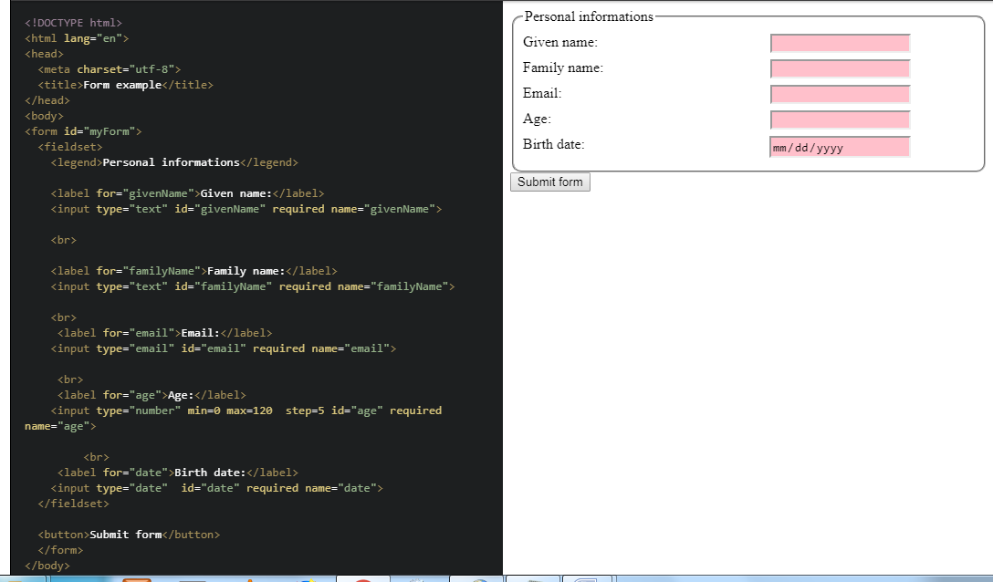

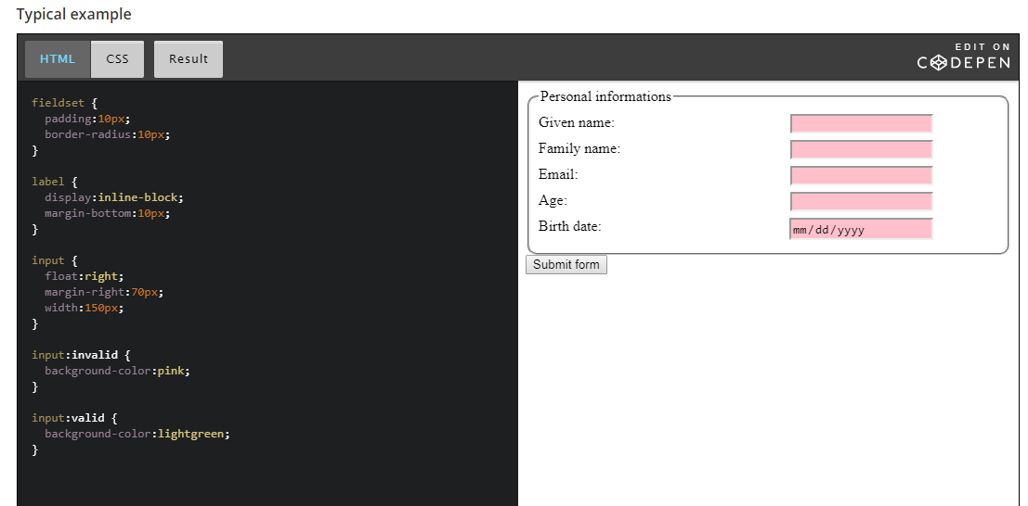

Note : Here invalid/valid is pseudo class of input element(pseudo class can be for any CSS selector of element.)

CSS Pseudo class/element - <https://developer.mozilla.org/en-US/docs/Web/CSS/Pseudo-classes>